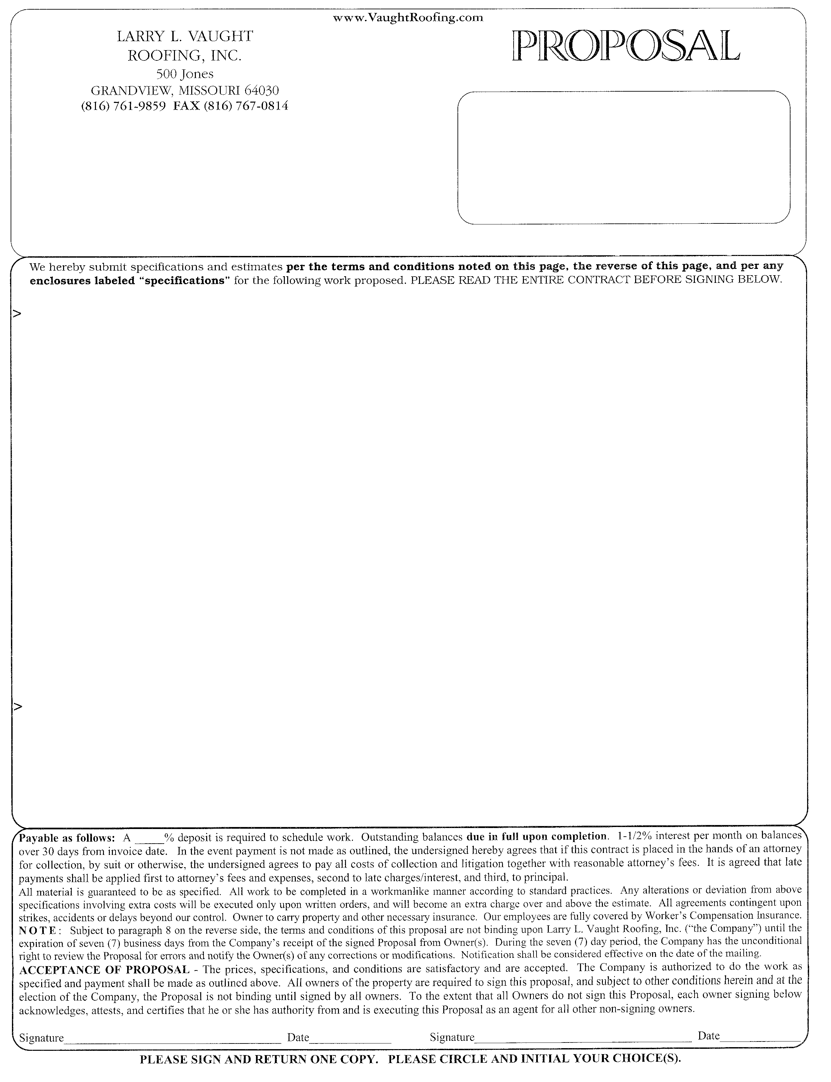
 |  |  |  | Job Name / Location
 |  |  |  | Job street address
 |  |  |  | Job site city, state, zip
 |  | To: | Customer Name | Cell:
 |  |  | Street address | Home: |  |  |  | Date
 |  |  | City, State, Zip | Work: |  |  |  | 2/2/2017
 |  |  |  | Email: |  |  |  |  |  |  |  |  | Overlay with
 |  |  |  | *We do not accept payment by credit card. |  |  |  |  |  |  |  |  | Furnish and install
Re-roof with composition shingles:
1 | ) | Remove and replace with GAF Royal Sovereign 25-Year composition shingles |  |  |  |  |  |  | = | $8,840.00
2 | ) | Remove and replace with GAF Timberline HD lifetime composition shingles |  |  |  |  |  |  | = | $9,030.00
3 | ) | Remove and replace with GAF Timberline ArmorShield II (impact resistant) lifetime composition shingles |  |  |  |  |  |  | = | $10,240.00
4 | ) | Remove and replace with GAF Camelot II lifetime composition shingles |  |  |  |  |  |  | = | $10,970.00
5 | ) | Remove and replace with GAF Grand Sequoia lifetime composition shingles |  |  |  |  |  |  | = | $11,060.00
6 | ) | Remove and replace with GAF Camelot lifetime composition shingles |  |  |  |  |  |  | = | $12,600.00
Bids include:
 | * | The GAF “System Plus” warranty coverage. *(Only available from GAF certified contractors.)
 | * | Removal of the one existing composition shingle roof layer and one existing cedar shingle roof layer.
 | * | Installation of 7/16” O.S.B. sheathing over the existing spaced sheathing.
 | * | Replacement of the flue vent pipe flashing.
 | * | Galvanized metal valley flashing of 24-inch width.
 | * | City reroof permit.
 | * | Removing and replacing the upper back low sloped roof section with a granular surfaced SBS modified bitumen membrane.
 | * | Installation of a sheet metal saddle behind the chimney.
 | * | Installation of an ice barrier underlayment along the roof eaves, extending 2-feet beyond exterior walls (where applicable).
 | * | Removing and replacing a portion of the cedar shingle siding only where and as necessary to install new step flashings where roof  adjoins siding. We will apply a coat of paint to the new shingle siding if paint is provided for our use when work is being completed.
Bids do not include:
 | * | The detached garage.
 | * | We find visible evidence of extensive hail damage to the roof.
Optional:
A | ) | Furnish and install a 3-foot wide pass of ice barrier underlayment beneath the new metal valley flashings. |  |  |  |  |  |  | = | $160.00
B | ) | Furnish & install GAF TimberTex Ridge in lieu of ridge field cut from GAF 25-year Royal Sovereign composition shingles as proposed. |  |  |  |  |  |  | = | $510.00
C | ) | Furnish and install additional passive roof vents. (Number suggested) |  |  |  |  | 2 |  | = | $70.00
D | ) | Furnish and install additional undereave vents. (Number suggested) |  |  |  |  | 2 |  | = | $80.00
E | ) | Replace the existing skylights (# indicated) with double pane curb mount skylights. |  |  |  |  | 1 |  | = | $385.00
F | ) | Furnish and install EZ-Lock black powder coated gutter screen on all gutters. |  |  |  |  |  |  | = | $320.00
 |  | Johnson County Contractor License #2016-1056 Kansas Registration #13-115236

